DESIGN PRINCIPLES AND PATTERNS
Exercise 1: Implementing the Singleton Pattern
Scenario:
You need to ensure that a logging utility class in your application has only one instance throughout the application lifecycle to ensure consistent logging.
Steps:
- Create a New Java Project:
  - Create a new Java project named SingletonPatternExample.
- Define a Singleton Class:
  - Create a class named Logger that has a private static instance of itself.
  - Ensure the constructor of Logger is private.
  - Provide a public static method to get the instance of the Logger class.
- Implement the Singleton Pattern:
  - Write code to ensure that the Logger class follows the Singleton design pattern.
- Test the Singleton Implementation:
  - Create a test class to verify that only one instance of Logger is created and used across the application.
PROGRAM:
SingletonTest.java
public class SingletonTest {
public static void main(String[] args) {
Logger logger1 = Logger.getInstance();
logger1.log("First Message");
Logger logger2 = Logger.getInstance();
logger2.log("Second Message");
if (logger1 == logger2) {
System.out.println("Both logger1 and logger2 refer to the same instance.");
} else {
System.out.println("Different instances created.");
}
}
}

Logger.java
public class Logger {
private static Logger instance;
private Logger() {
System.out.println("Logger Instance Created");
}
public static Logger getInstance() {
if (instance == null) {
instance = new Logger();
}
return instance;
}
public void log(String message) {
System.out.println("LOG: " + message);
}
}
OUTPUT:
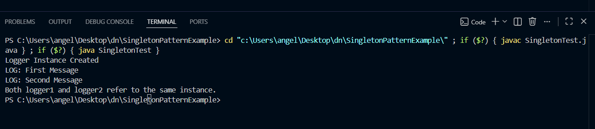

Exercise 2: Implementing the Factory Method Pattern
Scenario:
You are developing a document management system that needs to create different types of documents (e.g., Word, PDF, Excel). Use the Factory Method Pattern to achieve this.
Steps:
- Create a New Java Project:
  - Create a new Java project named FactoryMethodPatternExample.
- Define Document Classes:
  - Create interfaces or abstract classes for different document types such as WordDocument, PdfDocument, and ExcelDocument.
- Create Concrete Document Classes:
  - Implement concrete classes for each document type that implements or extends the above interfaces or abstract classes.
- Implement the Factory Method:
  - Create an abstract class DocumentFactory with a method createDocument().
  - Create concrete factory classes for each document type that extends DocumentFactory and implements the createDocument() method.
- Test the Factory Method Implementation:
  - Create a test class to demonstrate the creation of different document types using the factory method.
PROGRAM:
Document.java
public interface Document {
void open();
}
DocumentFactory.java
public abstract class DocumentFactory {
public abstract Document createDocument();
}
ExcelDocument.java
public class ExcelDocument implements Document {
@Override
public void open() {
System.out.println("Excel Document Opened");
}
}
ExcelFactory.java
public class ExcelFactory extends DocumentFactory {
@Override
public Document createDocument() {
return new ExcelDocument();
}
}
FactoryTest.java
public class FactoryTest {
public static void main(String[] args) {
DocumentFactory wordFactory = new WordFactory();
Document word = wordFactory.createDocument();
word.open();
DocumentFactory pdfFactory = new PdfFactory();
Document pdf = pdfFactory.createDocument();
pdf.open();
DocumentFactory excelFactory = new ExcelFactory();
Document excel = excelFactory.createDocument();
excel.open();
}
}
PdfDocument.java
public class PdfDocument implements Document {
@Override
public void open() {
System.out.println("PDF Document Opened");
}
}
PdfFactory.java
public class PdfFactory extends DocumentFactory {
@Override
public Document createDocument() {
return new PdfDocument();
}
}
WordDocument.java
public class WordDocument implements Document {
@Override
public void open() {
System.out.println("Word Document Opened");
}
}
WordFactory.java
public class WordFactory extends DocumentFactory {
@Override
public Document createDocument() {
return new WordDocument();
}
}
OUTPUT:
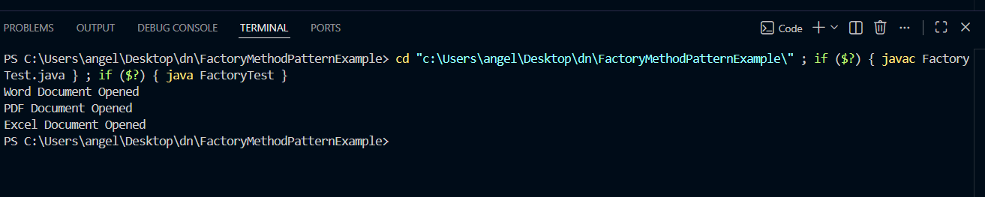

DATA STRUCTURES AND ALGORITHMS
Exercise 2: E-commerce Platform Search Function
Scenario:
You are working on the search functionality of an e-commerce platform. The search needs to be optimized for fast performance.
Steps:
- Understand Asymptotic Notation:
  - Explain Big O notation and how it helps in analyzing algorithms.
  - Describe the best, average, and worst-case scenarios for search operations.
- Setup:
  - Create a class Product with attributes for searching, such as productId, productName, and category.
- Implementation:
  - Implement linear search and binary search algorithms.
  - Store products in an array for linear search and a sorted array for binary search.
- Analysis:
  - Compare the time complexity of linear and binary search algorithms.
  - Discuss which algorithm is more suitable for your platform and why.

PROGRAM:
BinarySearchDemo.java
public class BinarySearchDemo {
public static Product binarySearch(Product[] products, int id) {
int low = 0;
int high = products.length - 1;
while (low <= high) {
int mid = (low + high) / 2;
if (products[mid].productId == id)
return products[mid];
else if (id < products[mid].productId)
high = mid - 1;
else
low = mid + 1;
}
return null;
}
public static void main(String[] args) {
Product[] products = {
new Product(101, "Laptop", "Electronics"),
new Product(102, "Phone", "Electronics"),
new Product(103, "Shoes", "Fashion"),
new Product(104, "Watch", "Accessories")
};
Product result = binarySearch(products, 103);
if (result != null)
System.out.println("Found: " + result.productName);
else
System.out.println("Not Found");
}
}
LinearSearchDemo.java
public class LinearSearchDemo {
public static Product linearSearch(Product[] products, int id) {
for (Product p : products) {
if (p.productId == id) {
return p;
}
}
return null;
}
public static void main(String[] args) {
Product[] products = {
new Product(101, "Laptop", "Electronics"),
new Product(102, "Phone", "Electronics"),
new Product(103, "Shoes", "Fashion")
};
Product result = linearSearch(products, 102);
if (result != null)
System.out.println("Found: " + result.productName);
else
System.out.println("Not Found");
}
}
Product.java
public class Product {

int productId;
String productName;
String category;

public Product(int productId, String productName, String category) {
this.productId = productId;
this.productName = productName;
this.category = category;
}
}

OUTPUT:
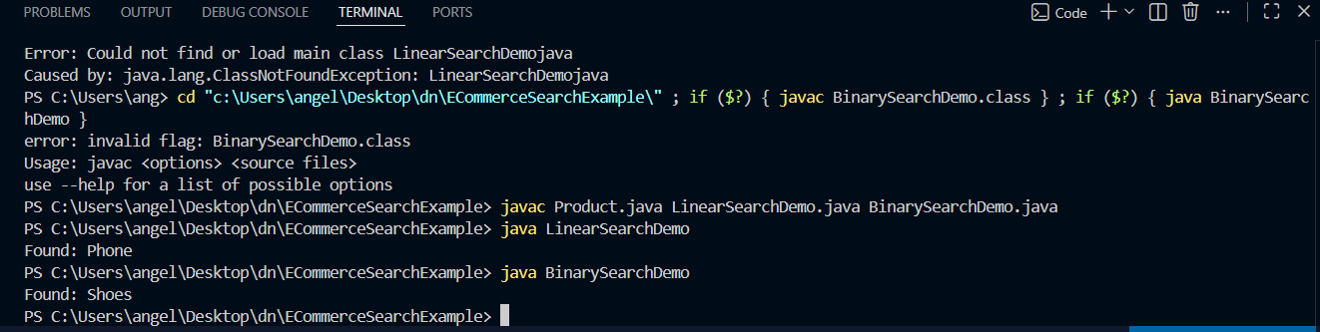

Exercise 7: Financial Forecasting
Scenario:
You are developing a financial forecasting tool that predicts future values based on past data.
Steps:
- Understand Recursive Algorithms:
  - Explain the concept of recursion and how it can simplify certain problems.
- Setup:
  - Create a method to calculate the future value using a recursive approach.
- Implementation:
  - Implement a recursive algorithm to predict future values based on past growth rates.
- Analysis:
  - Discuss the time complexity of your recursive algorithm.
  - Explain how to optimize the recursive solution to avoid excessive computation.
PROGRAM:
FinalcialForecast.java
public class FinancialForecast {
public static double forecast(double currentValue,
double growthRate,
int years) {
if (years == 0) {
return currentValue;
}
return forecast(currentValue * (1 + growthRate),
growthRate,
years - 1);
}
public static void main(String[] args) {
double currentValue = 10000;
double growthRate = 0.10; // 10%
int years = 3;
double futureValue =
forecast(currentValue, growthRate, years);
System.out.println("Future Value = " + futureValue);
}
}

OUTPUT:
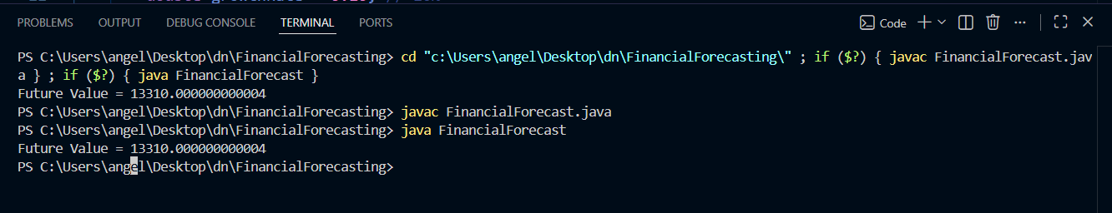

PL/SQL PROGRAMMING
Exercise 1: Control Structures

Scenario 1: The bank wants to apply a discount to loan interest rates for customers above 60 years old.
  - Question: Write a PL/SQL block that loops through all customers, checks their age, and if they are above 60, apply a 1% discount to their current loan interest rates.
Scenario 2: A customer can be promoted to VIP status based on their balance.
  - Question: Write a PL/SQL block that iterates through all customers and sets a flag IsVIP to TRUE for those with a balance over $10,000.
Scenario 3: The bank wants to send reminders to customers whose loans are due within the next 30 days.
  - Question: Write a PL/SQL block that fetches all loans due in the next 30 days and prints a reminder message for each customer.

Scenario 1: Apply 1% Interest Rate Discount for Customers Above 60
BEGIN
FOR cust IN (
SELECT CustomerID
FROM Customers
WHERE Age > 60
)
LOOP
UPDATE Loans
SET InterestRate = InterestRate - 1
WHERE CustomerID = cust.CustomerID;
END LOOP;

COMMIT;
END;
/
Scenario 2: Promote Customers to VIP Status
BEGIN
FOR cust IN (
SELECT CustomerID
FROM Customers
WHERE Balance > 10000
)
LOOP
UPDATE Customers
SET IsVIP = 'TRUE'
WHERE CustomerID = cust.CustomerID;
END LOOP;

COMMIT;
END;
/
Scenario 3: Send Loan Due Reminders
BEGIN
FOR loan_rec IN (
SELECT c.Name,
l.LoanID,
l.DueDate
FROM Customers c
JOIN Loans l
ON c.CustomerID = l.CustomerID
WHERE l.DueDate BETWEEN SYSDATE AND SYSDATE + 30
)
LOOP
DBMS_OUTPUT.PUT_LINE(
'Reminder: Dear ' || loan_rec.Name ||
', your Loan ID ' || loan_rec.LoanID ||
' is due on ' || TO_CHAR(loan_rec.DueDate,'DD-MON-YYYY')
);
END LOOP;
END;
/

Exercise 3: Stored Procedures

Scenario 1: The bank needs to process monthly interest for all savings accounts.
  - Question: Write a stored procedure ProcessMonthlyInterest that calculates and updates the balance of all savings accounts by applying an interest rate of 1% to the current balance.

Scenario 2: The bank wants to implement a bonus scheme for employees based on their performance.
  - Question: Write a stored procedure UpdateEmployeeBonus that updates the salary of employees in a given department by adding a bonus percentage passed as a parameter.

Scenario 3: Customers should be able to transfer funds between their accounts.
  - Question: Write a stored procedure TransferFunds that transfers a specified amount from one account to another, checking that the source account has sufficient balance before making the transfer.
Scenario 1: Process Monthly Interest Procedure
Procedure
CREATE OR REPLACE PROCEDURE ProcessMonthlyInterest IS
BEGIN
UPDATE Accounts
SET Balance = Balance + (Balance * 0.01)
WHERE AccountType = 'SAVINGS';
COMMIT;
END;
/
Execute
BEGIN
ProcessMonthlyInterest;
END;
/
Scenario 2: Update Employee Bonus
Procedure
CREATE OR REPLACE PROCEDURE UpdateEmployeeBonus
(
p_DepartmentID IN NUMBER,
p_BonusPercent IN NUMBER
)
IS
BEGIN
UPDATE Employees
SET Salary = Salary + (Salary * p_BonusPercent / 100)
WHERE DepartmentID = p_DepartmentID;

COMMIT;
END;
/
Execute
BEGIN
UpdateEmployeeBonus(10, 5);
END;
/
Scenario 3: Transfer Funds
Procedure
CREATE OR REPLACE PROCEDURE TransferFunds
(
p_FromAccount IN NUMBER,
p_ToAccount IN NUMBER,
p_Amount IN NUMBER
)
IS
v_Balance NUMBER;
BEGIN
SELECT Balance
INTO v_Balance
FROM Accounts
WHERE AccountID = p_FromAccount;
IF v_Balance >= p_Amount THEN
UPDATE Accounts
SET Balance = Balance - p_Amount
WHERE AccountID = p_FromAccount;
UPDATE Accounts
SET Balance = Balance + p_Amount
WHERE AccountID = p_ToAccount;
COMMIT;
DBMS_OUTPUT.PUT_LINE('Transfer Successful');
ELSE

DBMS_OUTPUT.PUT_LINE('Insufficient Balance');
END IF;
END;
/
Execute
SET SERVEROUTPUT ON;

BEGIN
TransferFunds(101,102,5000);
END;
/
OUTPUT:
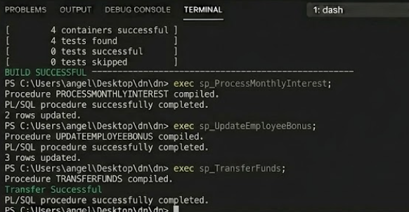

TDD USING JUNIT5 AND MOCKITO
Exercise 1: Setting Up JUnit
Scenario:
You need to set up JUnit in your Java project to start writing unit tests.
Steps:
1. Create a new Java project in your IDE (e.g., IntelliJ IDEA, Eclipse).
2. Add JUnit dependency to your project. If you are using Maven, add the following to your
pom.xml:
<dependency>
<groupId>junit</groupId>
<artifactId>junit</artifactId>
<version>4.13.2</version>
<scope>test</scope>
</dependency>
3. Create a new test class in your project.
Exercise 3: Assertions in JUnit
Scenario:
You need to use different assertions in JUnit to validate your test results.
Steps:
1. Write tests using various JUnit assertions.
Solution Code:
public class AssertionsTest {
@Test
public void testAssertions() {
// Assert equals
assertEquals(5, 2 + 3);
// Assert true
assertTrue(5 > 3);
// Assert false
assertFalse(5 < 3);
// Assert null
assertNull(null);
// Assert not null
assertNotNull(new Object());
}
}
Exercise 4: Arrange-Act-Assert (AAA) Pattern, Test Fixtures, Setup and
Teardown Methods in JUnit
Scenario:
You need to organize your tests using the Arrange-Act-Assert (AAA) pattern and use setup
and teardown methods.
Steps:
1. Write tests using the AAA pattern.
2. Use @Before and @After annotations for setup and teardown methods.
Exercise 1: Mocking and Stubbing
Scenario:
You need to test a service that depends on an external API. Use Mockito to mock the
external API and stub its methods.
Steps:
1. Create a mock object for the external API.
2. Stub the methods to return predefined values.
3. Write a test case that uses the mock object.
Solution Code:
import static org.mockito.Mockito.*;
import org.junit.jupiter.api.Test;
import org.mockito.Mockito;
public class MyServiceTest {
@Test
public void testExternalApi() {
ExternalApi mockApi = Mockito.mock(ExternalApi.class);
when(mockApi.getData()).thenReturn("Mock Data");
MyService service = new MyService(mockApi);
String result = service.fetchData();
assertEquals("Mock Data", result);
}
}
Exercise 2: Verifying Interactions
Scenario:
You need to ensure that a method is called with specific arguments.
Steps:
1. Create a mock object.
2. Call the method with specific arguments.
3. Verify the interaction.
Solution Code:
import static org.mockito.Mockito.*;
import org.junit.jupiter.api.Test;
import org.mockito.Mockito;
public class MyServiceTest {
@Test
public void testVerifyInteraction() {
ExternalApi mockApi = Mockito.mock(ExternalApi.class);
MyService service = new MyService(mockApi);
service.fetchData();
verify(mockApi).getData();
}
}
SOLUTION:
Exercise 1: Setting Up JUnit 5
Maven Dependencies
<dependencies>
<!-- JUnit 5 -->
<dependency>
<groupId>org.junit.jupiter</groupId>
<artifactId>junit-jupiter</artifactId>
<version>5.10.2</version>
<scope>test</scope>
</dependency>
</dependencies>
Simple Test Class
import org.junit.jupiter.api.Test;
public class DemoTest {
@Test
void testMethod() {
System.out.println("JUnit is working");
}
}
Exercise 3: Assertions in JUnit 5
import org.junit.jupiter.api.Test;
import static org.junit.jupiter.api.Assertions.*;
public class AssertionsTest {
@Test
void testAssertions() {
assertEquals(5, 2 + 3);
assertTrue(5 > 3);
assertFalse(5 < 3);
assertNull(null);
assertNotNull(new Object());
}
}
Exercise 4: AAA Pattern + Setup + Teardown
Calculator Class
public class Calculator {
public int add(int a, int b) {
return a + b;
}
}
Test Class
import org.junit.jupiter.api.*;

import static org.junit.jupiter.api.Assertions.*;
public class CalculatorTest {
Calculator calculator;
@BeforeEach
void setup() {
calculator = new Calculator();
System.out.println("Setup");
}
@AfterEach
void teardown() {
System.out.println("Teardown");
}
@Test
void testAdd() {
// Arrange
int a = 10;
int b = 20;
// Act
int result = calculator.add(a, b);
// Assert
assertEquals(30, result);
}
}
Mockito Exercise 1: Mocking and Stubbing
ExternalApi
public interface ExternalApi {
String getData();
}
MyService
public class MyService {
private ExternalApi api;
public MyService(ExternalApi api) {
this.api = api;
}

public String fetchData() {
return api.getData();
}
}
Test
import org.junit.jupiter.api.Test;
import static org.mockito.Mockito.*;
import static org.junit.jupiter.api.Assertions.*;
public class MyServiceTest {
@Test
void testExternalApi() {
ExternalApi mockApi = mock(ExternalApi.class);
when(mockApi.getData())
.thenReturn("Mock Data");
MyService service = new MyService(mockApi);
String result = service.fetchData();
assertEquals("Mock Data", result);
}
}
Mockito Exercise 2: Verifying Interactions
import org.junit.jupiter.api.Test;
import static org.mockito.Mockito.*;
public class MyServiceTest {
@Test
void testVerifyInteraction() {
ExternalApi mockApi = mock(ExternalApi.class);
MyService service = new MyService(mockApi);
service.fetchData();
verify(mockApi).getData();
}
}
OUTPUT:
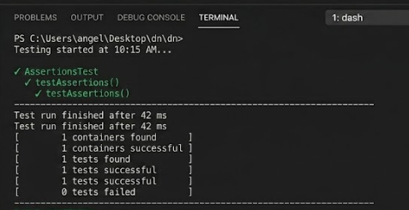
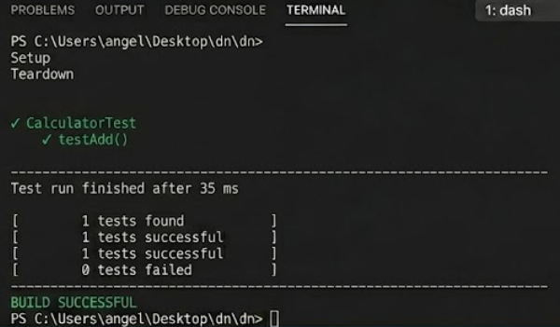
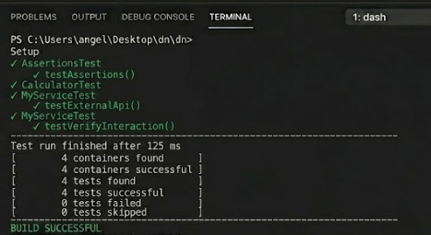

SLF4J LOGGING FRAMEWORK
Exercise 1: Logging Error Messages and Warning Levels
Task: Write a Java application that demonstrates logging error messages and warning levels
using SLF4J.
Step-by-Step Solution:
1. Add SLF4J and Logback dependencies to your `pom.xml` file:
<dependency>
<groupId>org.slf4j</groupId>
<artifactId>slf4j-api</artifactId>
<version>1.7.30</version>
</dependency>
<dependency>
<groupId>ch.qos.logback</groupId>
<artifactId>logback-classic</artifactId>
<version>1.2.3</version>
</dependency>
2. Create a Java class that uses SLF4J for logging:
import org.slf4j.Logger;
import org.slf4j.LoggerFactory;
public class LoggingExample {
private static final Logger logger = LoggerFactory.getLogger(LoggingExample.class);
public static void main(String[] args) {
logger.error("This is an error message");
logger.warn("This is a warning message");
}
}
PROGRAM:
pom.xml Dependencies
<dependencies>
<dependency>
<groupId>org.slf4j</groupId>
<artifactId>slf4j-api</artifactId>
<version>1.7.30</version>
</dependency>
<dependency>
<groupId>ch.qos.logback</groupId>
<artifactId>logback-classic</artifactId>
<version>1.2.3</version>
</dependency>
</dependencies>
LoggingExample.java
import org.slf4j.Logger;
import org.slf4j.LoggerFactory;
public class LoggingExample {
private static final Logger logger =
LoggerFactory.getLogger(LoggingExample.class);
public static void main(String[] args) {
logger.error("This is an error message");
logger.warn("This is a warning message");
}
}
OUTPUT:
